**PINE S7 Board**

Getting Started with Vivado Microblaze Design Using PINE S7 FPGA kit

This Tutorial provides step by step procedure and run Microblaze design on PINE S7 kit. Firstly, create design in Vivado 2018.2. and run software application on PINE S7. The peripheral application is demo outputs LED Blinking and terminal output.

**MicroBlaze IP** is a **soft processor core** developed by Xilinx specifically designed for their FPGA (Field-Programmable Gate Array) families. Being a "soft" processor means that the MicroBlaze core is implemented using the FPGA's configurable logic blocks rather than being a fixed hardware component. This flexibility allows designers to tailor the processor's features and performance to suit the specific needs of their application.

We are creating design in vivado 2018.2 follow all steps properly and then we are going to launch SDK after export hardware design then BMM/MMI file will create, we have to program .bit file and BMM/MMI file in FPGA through SDK and similarly the .XSA file will create for Vitis if Vitis is installed in your PC/Laptop then update hardware specification where have to upload .XSA file. Now we are going to use SDK here.

**Step 1** We are creating new project here so Open Vivado > Create project > New > Choose Directory

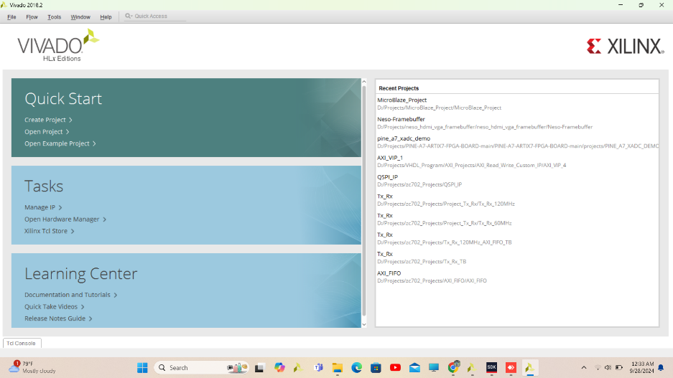

**Step 2** To create a Vivado project you will need to provide a name and a location for your project files. Next, you will specify the type of flow you will be working with. Finally, you will specify your project source and choose a default part. Click on **Next**

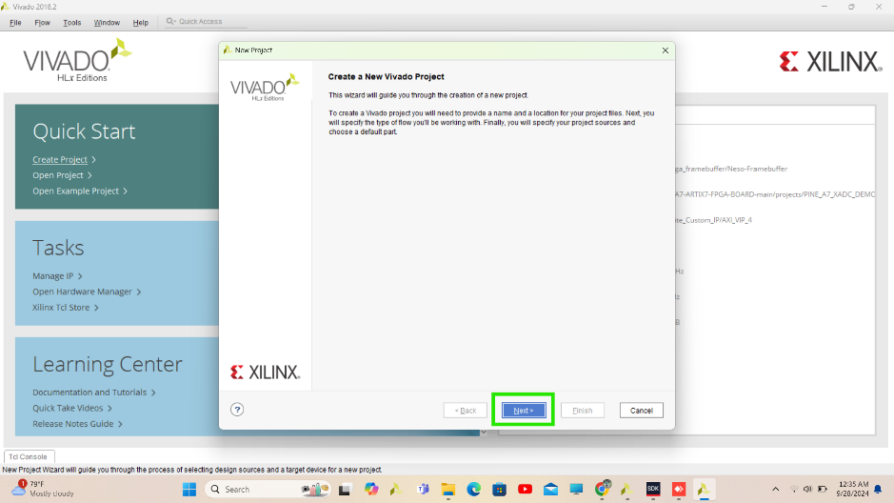

**Step 3** Enter a name for your project and specify a directory where the project data files will be stored

Click on **NEXT**.

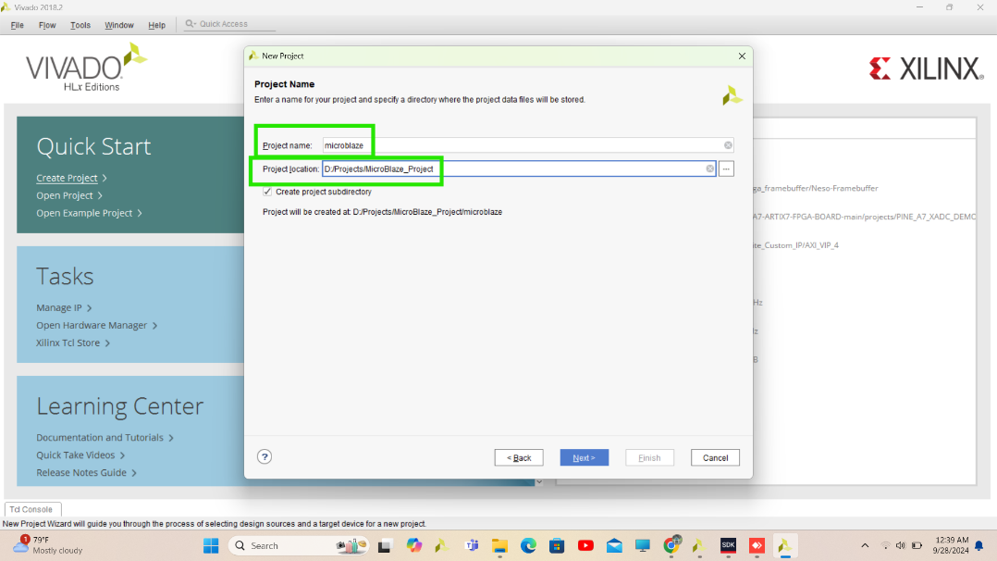

**Step 4** Specify the type of project to create Here we are going to create RTL Project so Choose RTL Project and click on **Next**

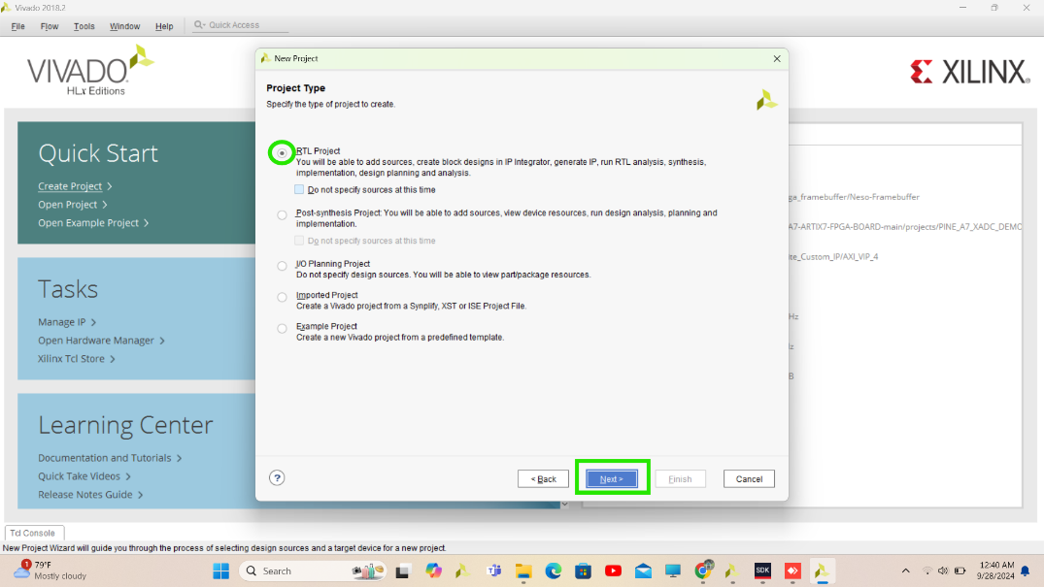

**Step 5** Here we can add or create new Hardware files. We will add constraint file after complete block design we are going to create Block design using IP’s so click **Next** here.

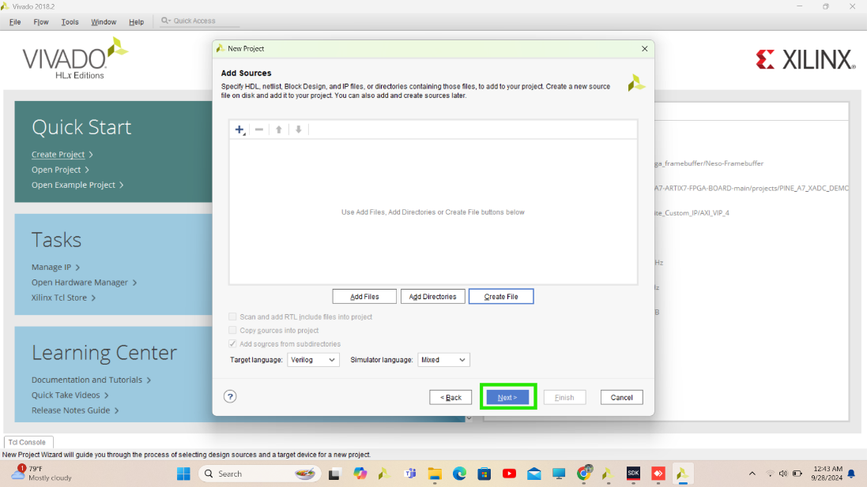

**Step 6** Here we can add constraint file for interfacing our design’s IO pins with FPGA’S pin no. we will create it later.

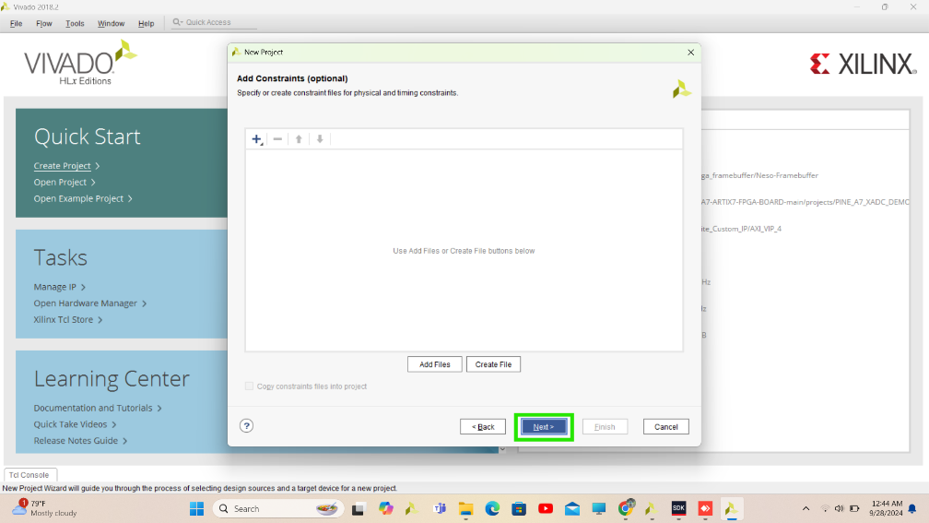

**Step 7** Choose Part no. of FPGA which is **xc7s15ftgb196-1**

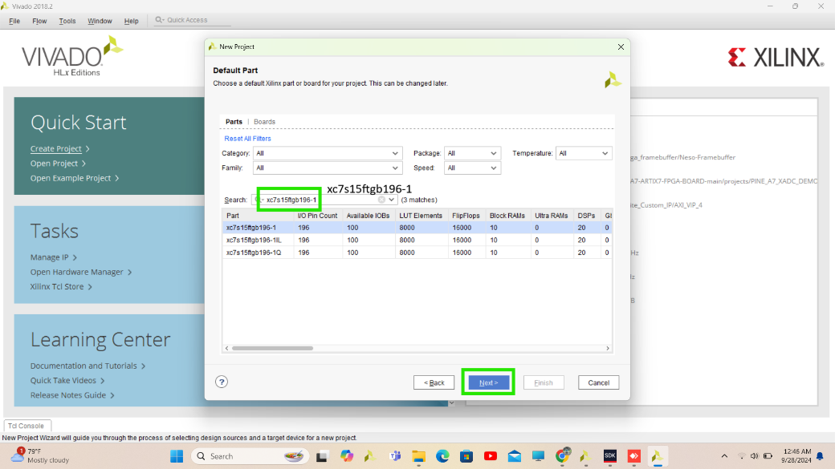

**Step 8** Now theProject summary will display with selected project details. Check it and properly and click on **Finish**

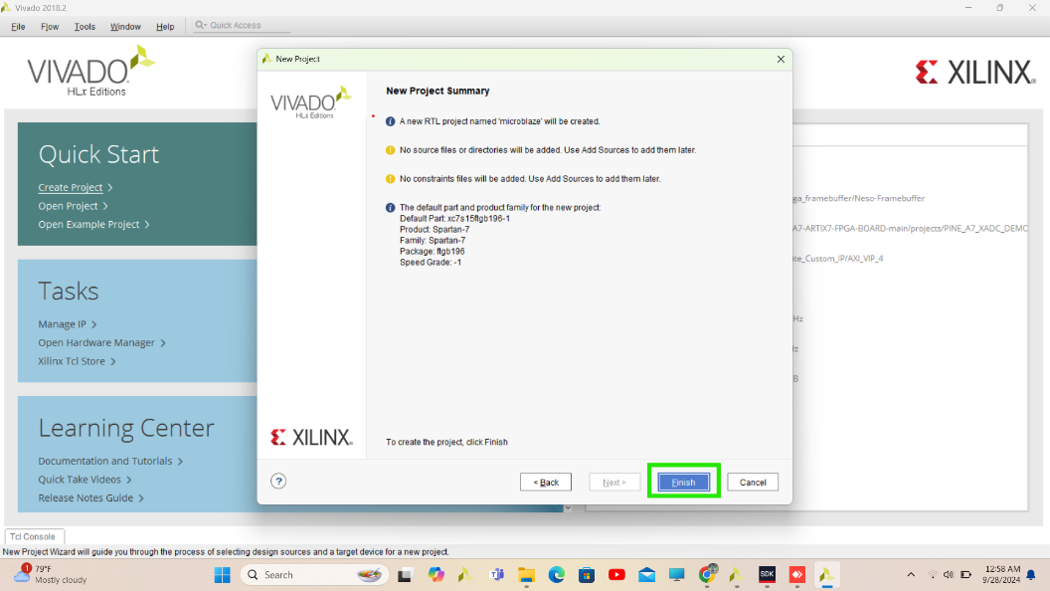

**Step 9** Now the Vivado tool will opens with flow navigation on left side in PROJECT MANAGER. Click on create clock design.

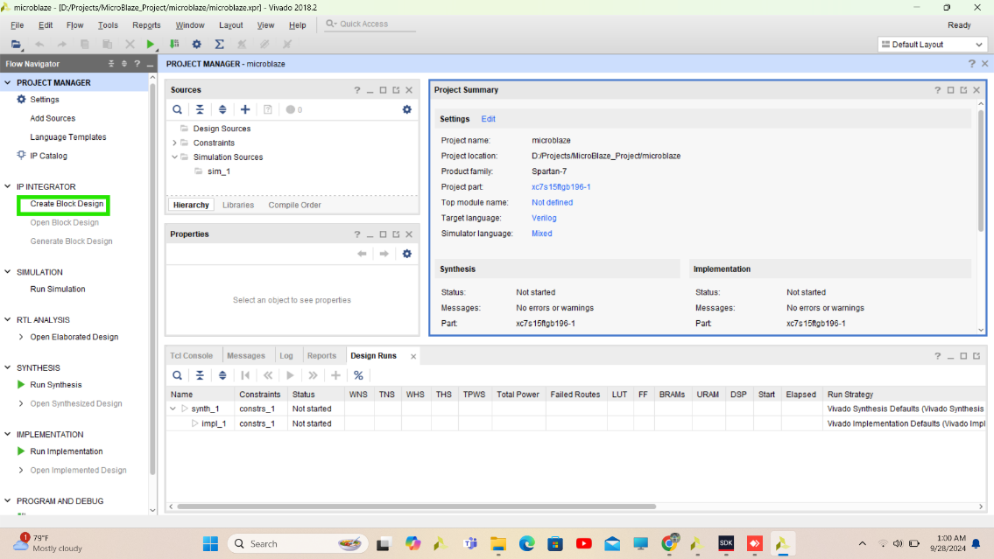

**Step 10** specify block design name here I use default name you can change it according to you and click **OK.**

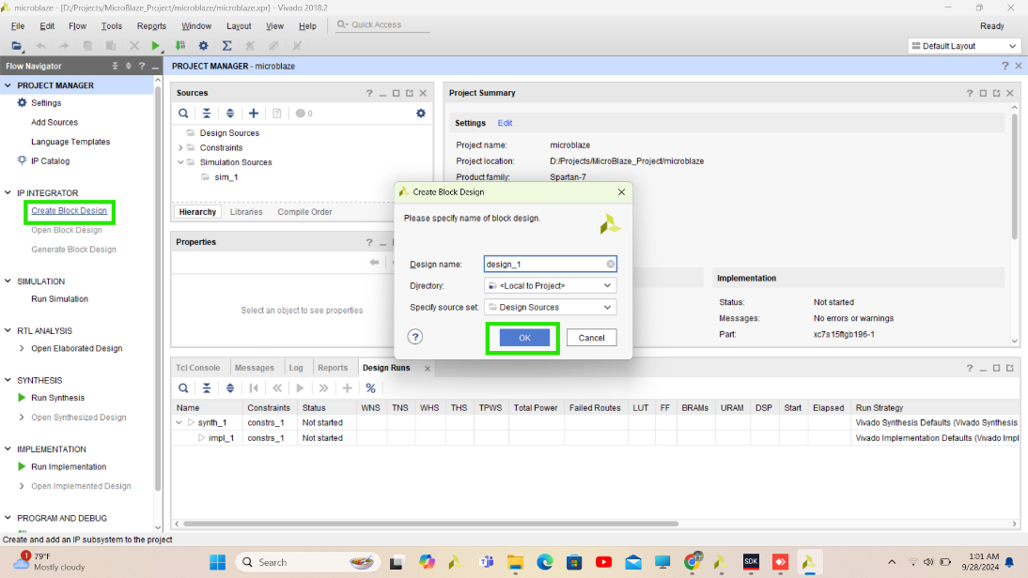

**Step 11** Click on + sign to Add IP to add IPs in design. Here you will get available IP’s in Vivado.

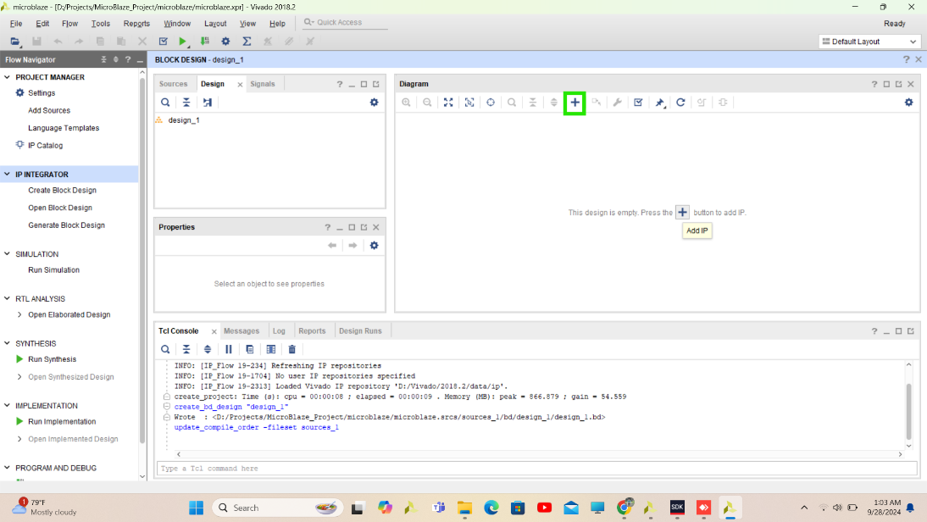

**Step 12** We have to add Microblaze IP so search Microblaze and double click on MicroBlaze IP to add it your design.

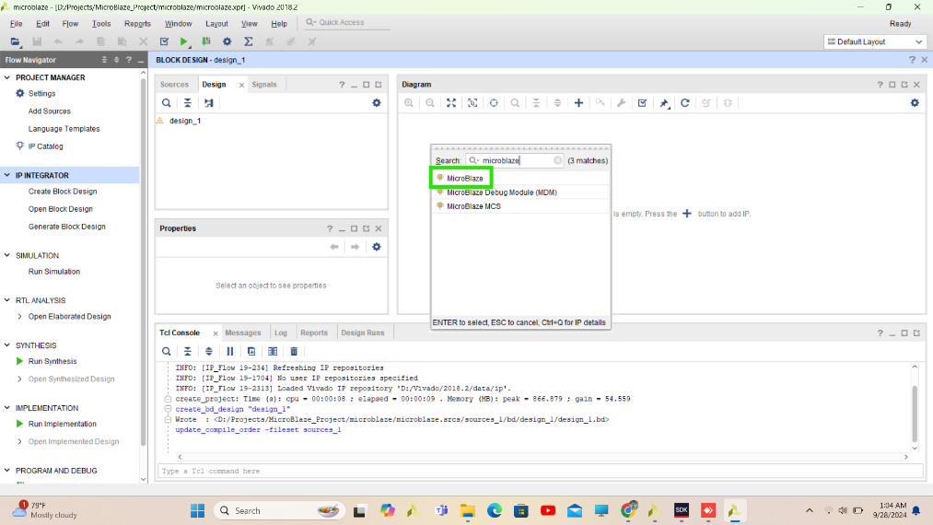

**Step 13** Similarly add AXI GPIO module (It is designed to facilitate communication between the programmable logic (FPGA fabric) and external devices or peripherals through general-purpose I/O (GPIO) pins using the **AXI (Advanced eXtensible Interface)** protocol. The AXI GPIO IP core is a versatile and configurable component that allows designers to implement flexible input and output interfaces within their FPGA designs, enabling interaction with a wide range of external hardware)

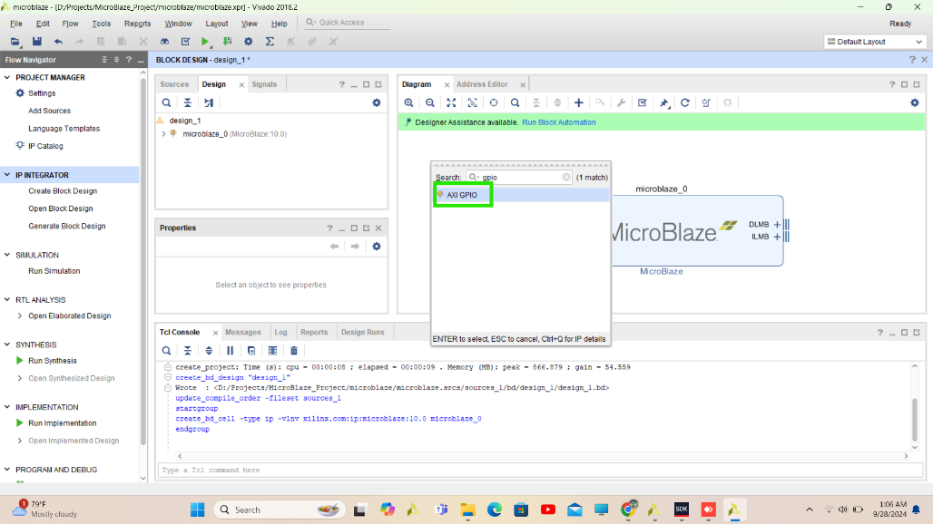

**Step 14** Similarly add clock wizard (This IP generate various clock signals within an FPGA design)

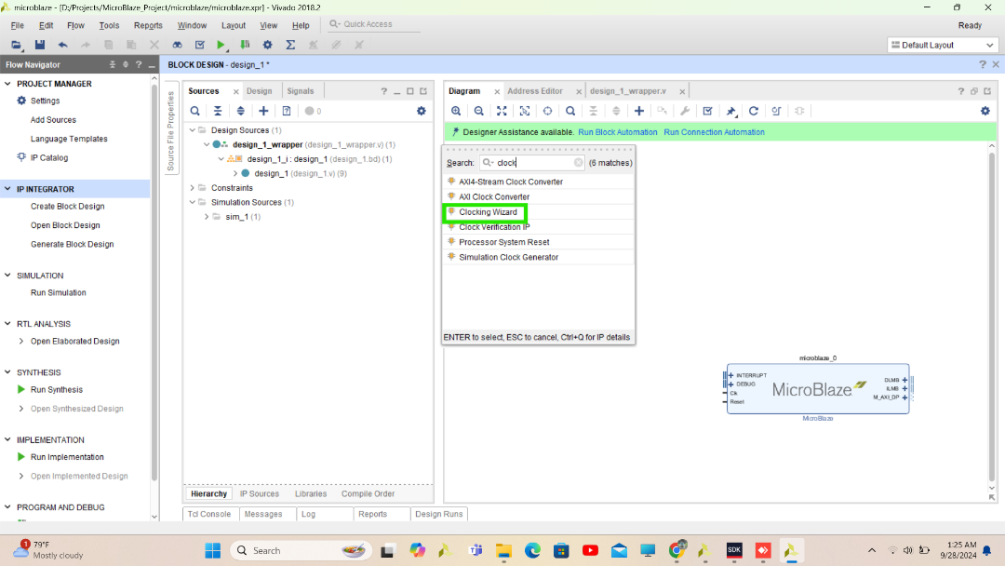

**Step 15** Add AXI UarTL LTE (Using UART IP we will print statement in serial terminal)

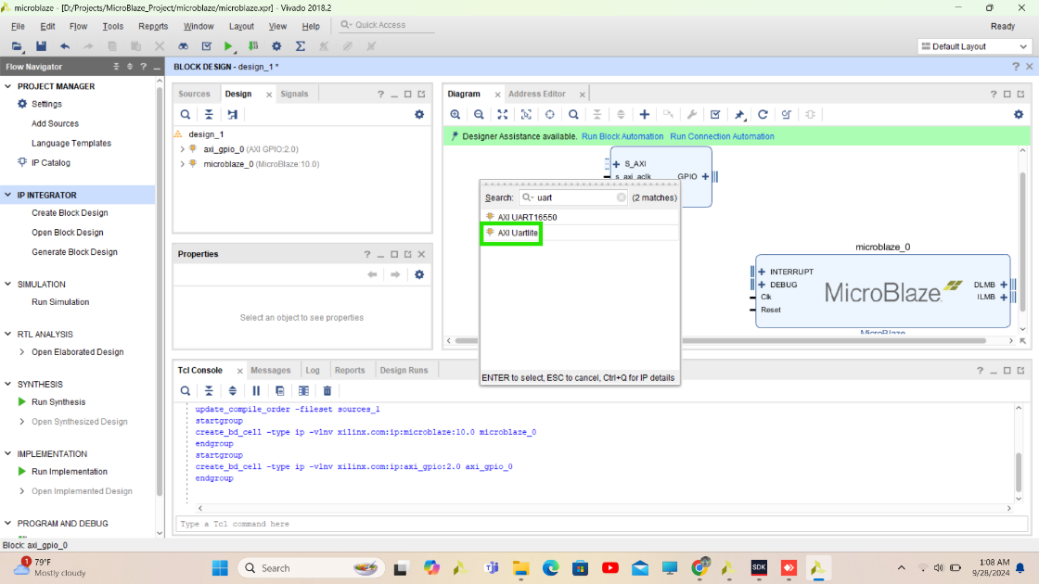

**Step 16** Run Block automation and Run Connection Automation. Or you can connect it manually also.

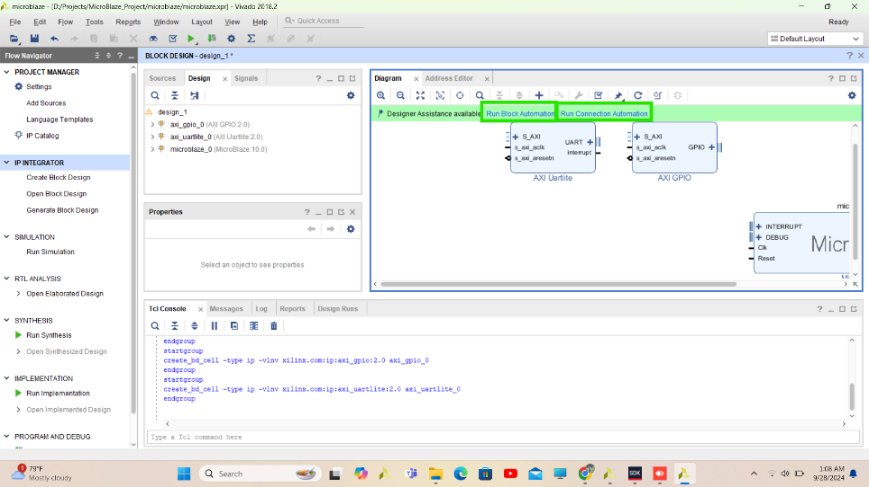

**Step 17** Tick here for GPIO and UART automatic connection

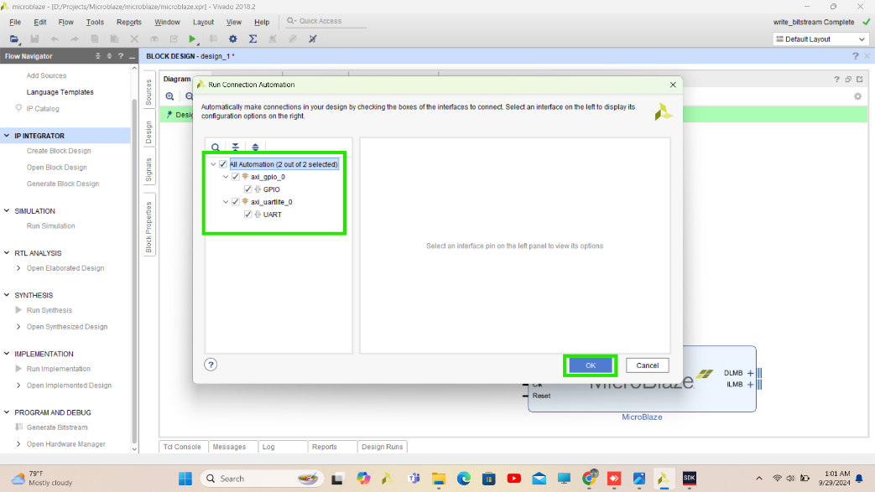

**Step 18** after Run block automation to choose Microblaze’s configuration.

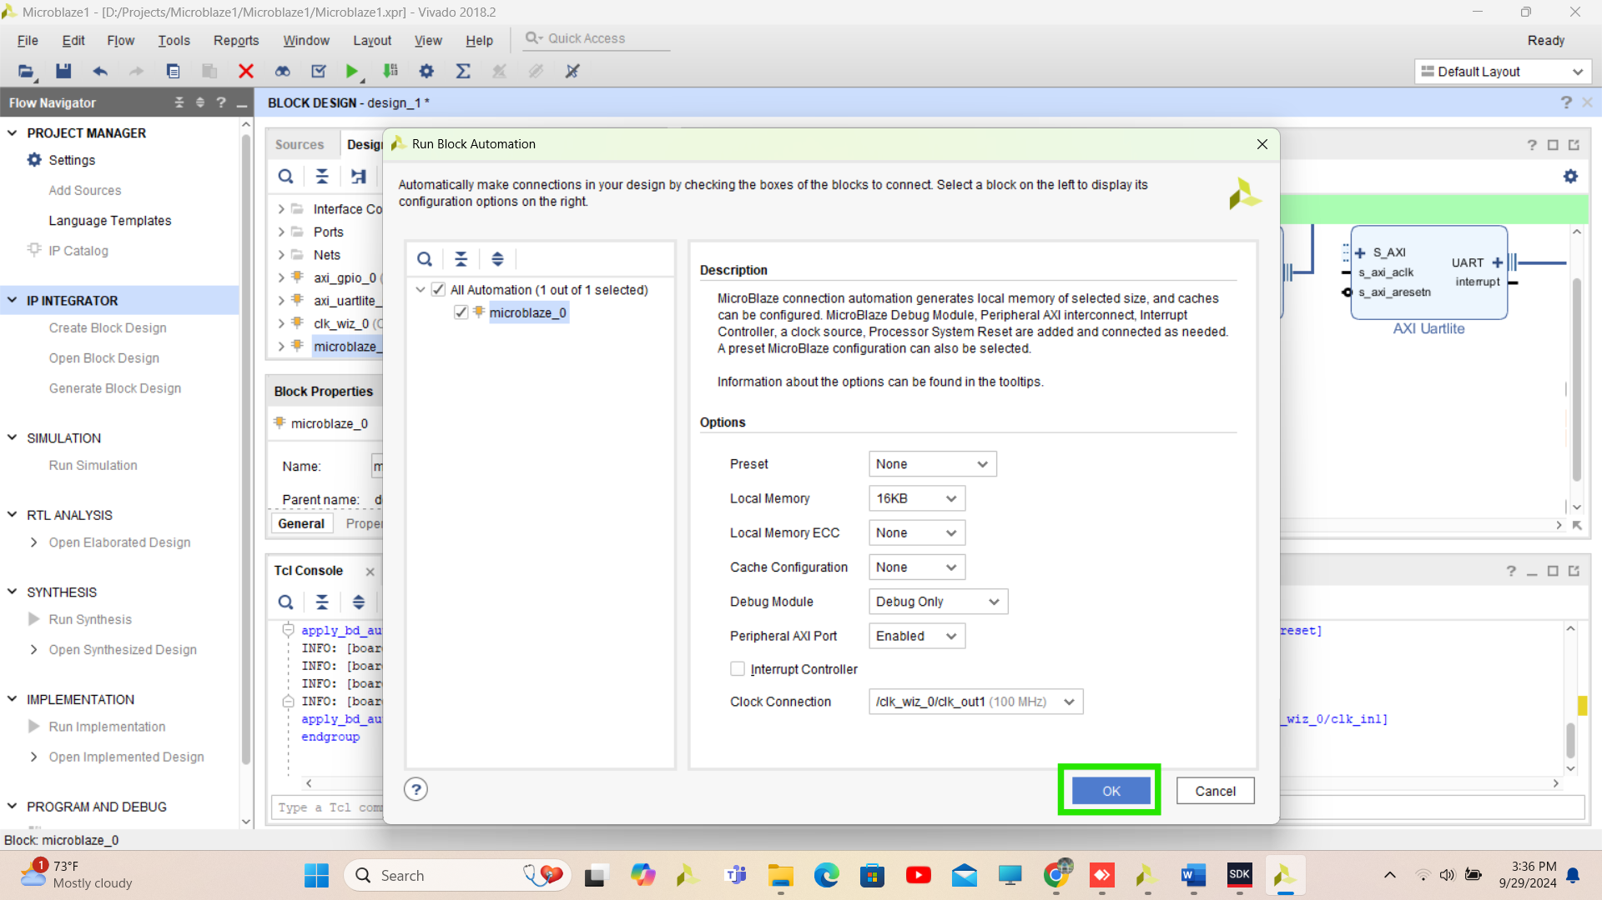

**Step 19** Below fig is complete block design of project but we have to add a not gate for reset so our output will get without pressing key button where we are going to connect out reset pin

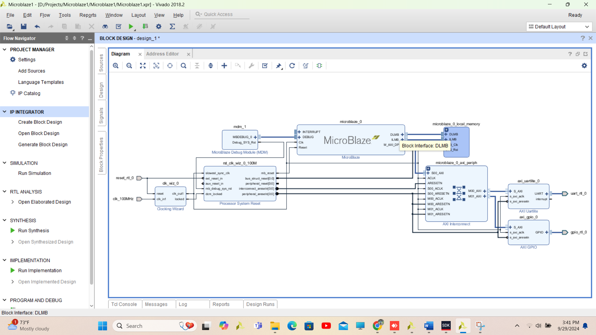

**Step 20** Add IP to add Utility Logic Vector. Here we have to add NOT Gate for reset because we are going to connect this reset pin to the trigger button on a board if we didn’t add NOT Gate then design will be in reset mode and it will work only by pressing button.

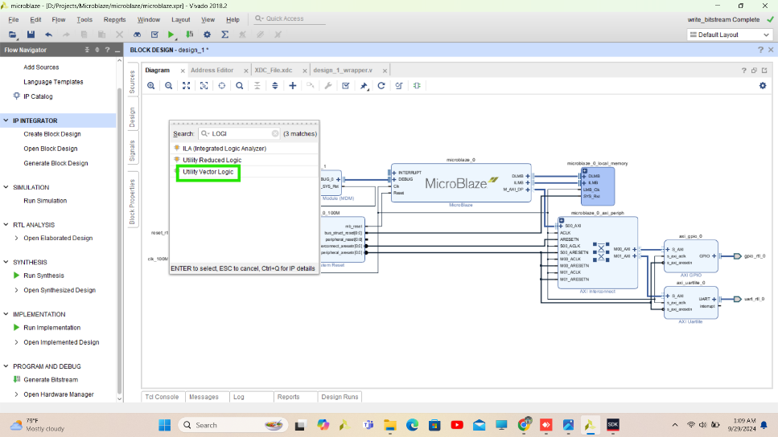

**Step 21** Double click on logic gate and select not gate and change C_SIZE 1 Bit.

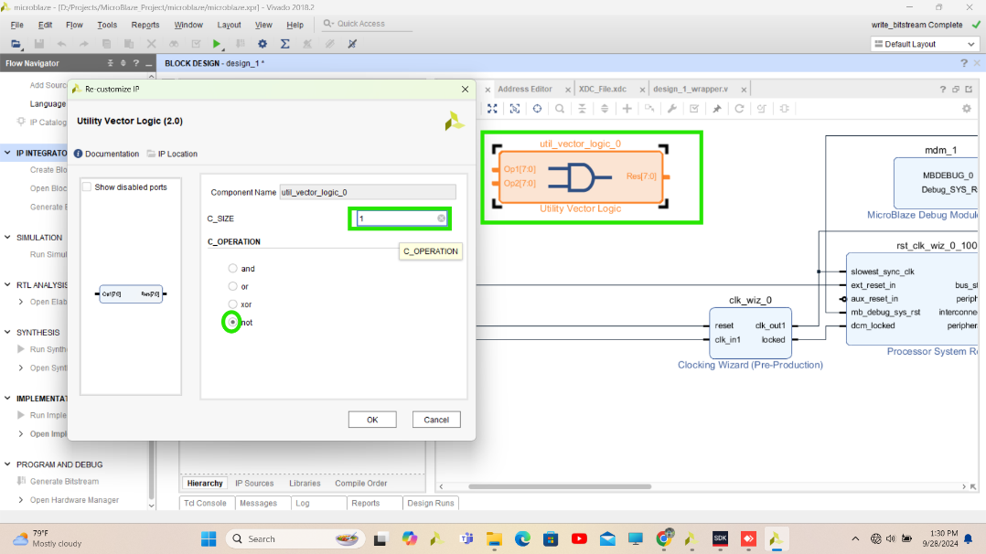

**Step 22** Right click on reset port and disconnect pin and reconnect it through not gate.

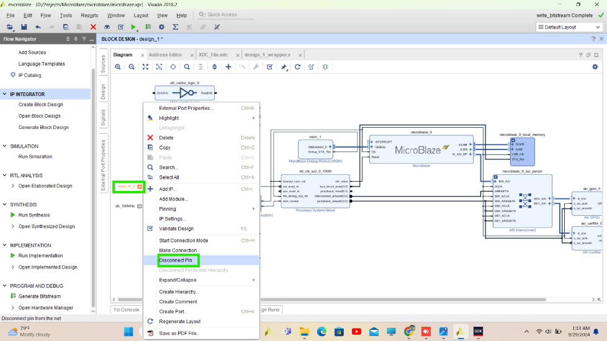

**Step 23** Before proceed next change GPIO 32 Bit to 16 Bit output by double click on AXI GPIO

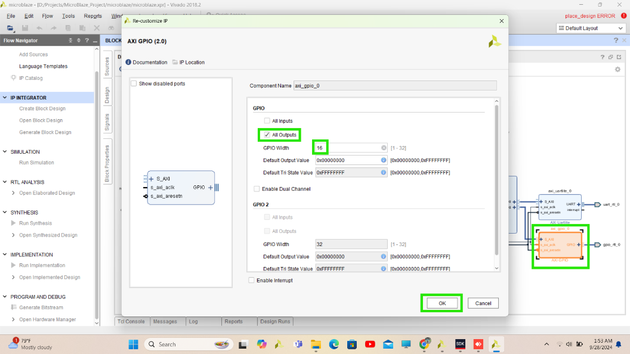

**Step 24** Click on Regenerate layout to Auto arrange all IP’s and click on validate design to validate all connection.

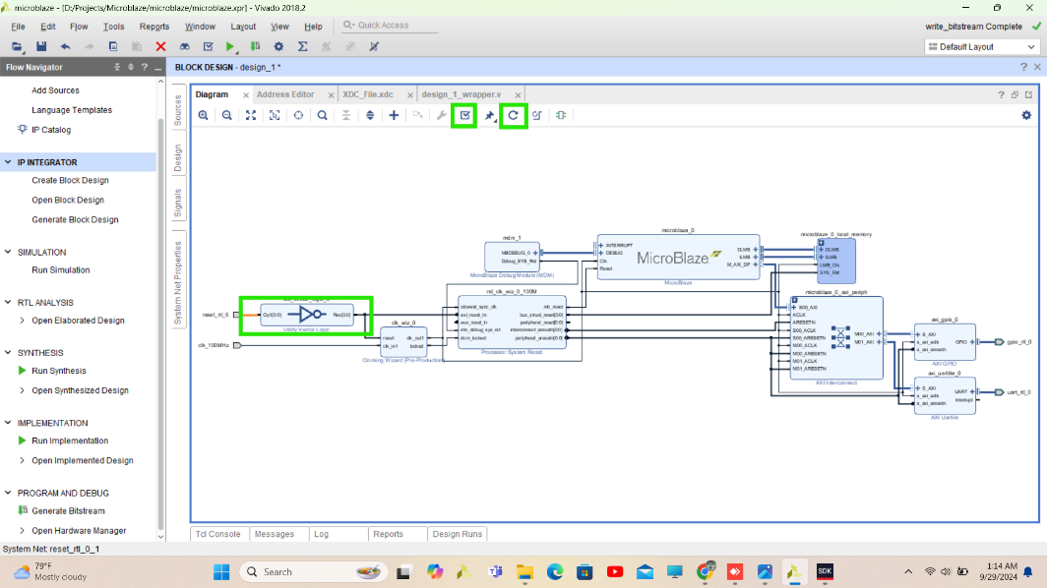

**Step 25** Here Block design is completed Now right click on design_1 from source and create HDL Wrapper to get HDL File for IO ports of Block design.

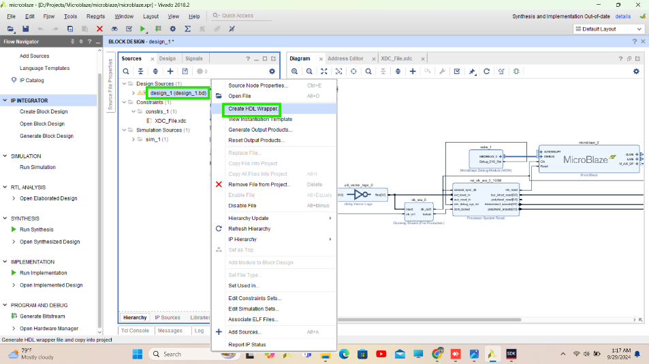

**Step 26** Now Design is almost completed. Now Create Constraint file

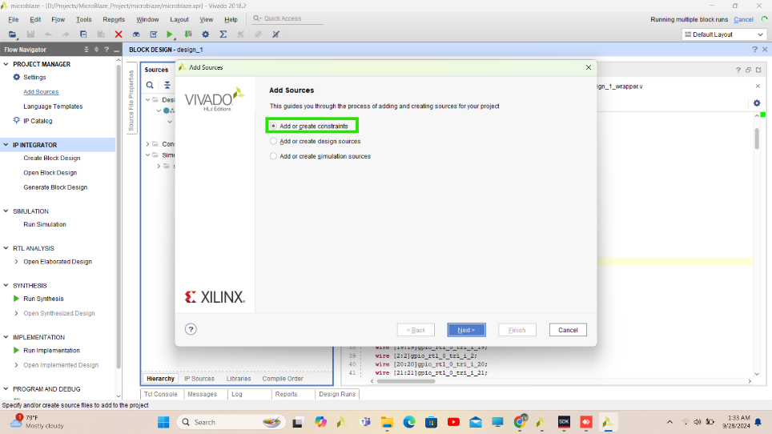

**Step 27** Specify the name to XDC File (Constraint file)

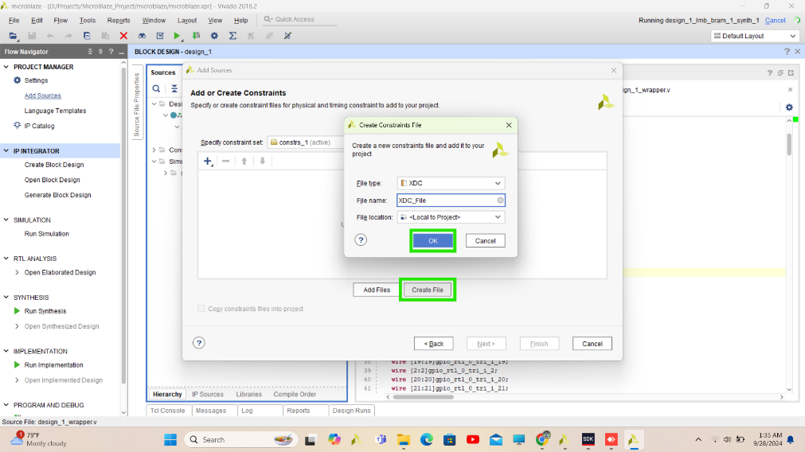

**Step 28** In Constraint file connect io port names properly from design_1_Wrapper.v file to the FPGA Pins properly.

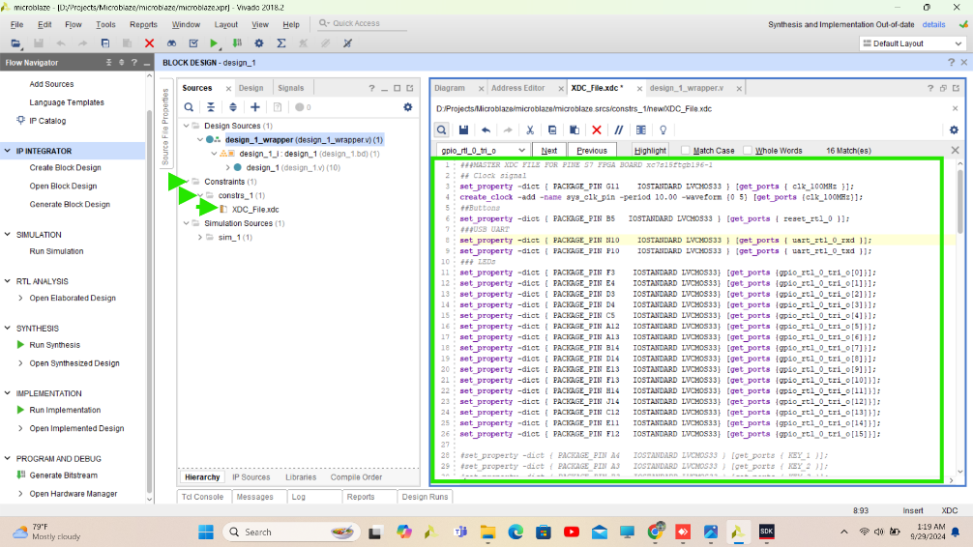

Here is complete constraint file for PINE S7 Board

###MASTER XDC FILE FOR PINE S7 FPGA BOARD xc7s15ftgb196-1

## Clock signal

set_property -dict { PACKAGE_PIN G11 IOSTANDARD LVCMOS33 } [get_ports { clk_100MHz }];

create_clock -add -name sys_clk_pin -period 10.00 -waveform {0 5} [get_ports {clk_100MHz}];

##Buttons

set_property -dict { PACKAGE_PIN B5 IOSTANDARD LVCMOS33 } [get_ports { reset_rtl_0 }];

###USB UART

set_property -dict { PACKAGE_PIN N10 IOSTANDARD LVCMOS33 } [get_ports { uart_rtl_0_rxd }];

set_property -dict { PACKAGE_PIN P10 IOSTANDARD LVCMOS33 } [get_ports { uart_rtl_0_txd }];

### LEDs

set_property -dict { PACKAGE_PIN F3 IOSTANDARD LVCMOS33} [get_ports {gpio_rtl_0_tri_o[0]}];

set_property -dict { PACKAGE_PIN E4 IOSTANDARD LVCMOS33} [get_ports {gpio_rtl_0_tri_o[1]}];

set_property -dict { PACKAGE_PIN D3 IOSTANDARD LVCMOS33} [get_ports {gpio_rtl_0_tri_o[2]}];

set_property -dict { PACKAGE_PIN D4 IOSTANDARD LVCMOS33} [get_ports {gpio_rtl_0_tri_o[3]}];

set_property -dict { PACKAGE_PIN C5 IOSTANDARD LVCMOS33} [get_ports {gpio_rtl_0_tri_o[4]}];

set_property -dict { PACKAGE_PIN A12 IOSTANDARD LVCMOS33} [get_ports {gpio_rtl_0_tri_o[5]}];

set_property -dict { PACKAGE_PIN A13 IOSTANDARD LVCMOS33} [get_ports {gpio_rtl_0_tri_o[6]}];

set_property -dict { PACKAGE_PIN B14 IOSTANDARD LVCMOS33} [get_ports {gpio_rtl_0_tri_o[7]}];

set_property -dict { PACKAGE_PIN D14 IOSTANDARD LVCMOS33} [get_ports {gpio_rtl_0_tri_o[8]}];

set_property -dict { PACKAGE_PIN E13 IOSTANDARD LVCMOS33} [get_ports {gpio_rtl_0_tri_o[9]}];

set_property -dict { PACKAGE_PIN F13 IOSTANDARD LVCMOS33} [get_ports {gpio_rtl_0_tri_o[10]}];

set_property -dict { PACKAGE_PIN H14 IOSTANDARD LVCMOS33} [get_ports {gpio_rtl_0_tri_o[11]}];

set_property -dict { PACKAGE_PIN J14 IOSTANDARD LVCMOS33} [get_ports {gpio_rtl_0_tri_o[12]}];

set_property -dict { PACKAGE_PIN C12 IOSTANDARD LVCMOS33} [get_ports {gpio_rtl_0_tri_o[13]}];

set_property -dict { PACKAGE_PIN E11 IOSTANDARD LVCMOS33} [get_ports {gpio_rtl_0_tri_o[14]}];

set_property -dict { PACKAGE_PIN F12 IOSTANDARD LVCMOS33} [get_ports {gpio_rtl_0_tri_o[15]}];

#set_property -dict { PACKAGE_PIN A4 IOSTANDARD LVCMOS33 } [get_ports { KEY_1 }];

#set_property -dict { PACKAGE_PIN A3 IOSTANDARD LVCMOS33 } [get_ports { KEY_2 }];

#set_property -dict { PACKAGE_PIN B3 IOSTANDARD LVCMOS33 } [get_ports { KEY_3 }];

##Slide Switches

#set_property -dict { PACKAGE_PIN A5 IOSTANDARD LVCMOS33 } [get_ports { SLIDE_SW[0] }];

#set_property -dict { PACKAGE_PIN B6 IOSTANDARD LVCMOS33 } [get_ports { SLIDE_SW[1] }];

#set_property -dict { PACKAGE_PIN F4 IOSTANDARD LVCMOS33 } [get_ports { SLIDE_SW[2] }];

#set_property -dict { PACKAGE_PIN C3 IOSTANDARD LVCMOS33 } [get_ports { SLIDE_SW[3] }];

#set_property -dict { PACKAGE_PIN C4 IOSTANDARD LVCMOS33 } [get_ports { SLIDE_SW[4] }];

#set_property -dict { PACKAGE_PIN A10 IOSTANDARD LVCMOS33 } [get_ports { SLIDE_SW[5] }];

#set_property -dict { PACKAGE_PIN B13 IOSTANDARD LVCMOS33 } [get_ports { SLIDE_SW[6] }];

#set_property -dict { PACKAGE_PIN C14 IOSTANDARD LVCMOS33 } [get_ports { SLIDE_SW[7] }];

#set_property -dict { PACKAGE_PIN D13 IOSTANDARD LVCMOS33 } [get_ports { SLIDE_SW[8] }];

#set_property -dict { PACKAGE_PIN F14 IOSTANDARD LVCMOS33 } [get_ports { SLIDE_SW[9] }];

#set_property -dict { PACKAGE_PIN G14 IOSTANDARD LVCMOS33 } [get_ports { SLIDE_SW[10] }];

#set_property -dict { PACKAGE_PIN H13 IOSTANDARD LVCMOS33 } [get_ports { SLIDE_SW[11] }];

#set_property -dict { PACKAGE_PIN D12 IOSTANDARD LVCMOS33 } [get_ports { SLIDE_SW[12] }];

#set_property -dict { PACKAGE_PIN E12 IOSTANDARD LVCMOS33 } [get_ports { SLIDE_SW[13] }];

#set_property -dict { PACKAGE_PIN F11 IOSTANDARD LVCMOS33 } [get_ports { SLIDE_SW[14] }];

#set_property -dict { PACKAGE_PIN H11 IOSTANDARD LVCMOS33 } [get_ports { SLIDE_SW[15] }];

###Buzzer

#set_property -dict { PACKAGE_PIN P3 IOSTANDARD LVCMOS33 } [get_ports { BUZZER}];

###RGB LED

#set_property -dict { PACKAGE_PIN H12 IOSTANDARD LVCMOS33 } [get_ports { LED_BLUE}];

#set_property -dict { PACKAGE_PIN J12 IOSTANDARD LVCMOS33 } [get_ports { LED_GREEN}];

#set_property -dict { PACKAGE_PIN J11 IOSTANDARD LVCMOS33 } [get_ports { LED_RED}];

###seven segment

#set_property -dict { PACKAGE_PIN G4 IOSTANDARD LVCMOS33 } [get_ports { SIG_A }];

#set_property -dict { PACKAGE_PIN H3 IOSTANDARD LVCMOS33 } [get_ports { SIG_B }];

#set_property -dict { PACKAGE_PIN J3 IOSTANDARD LVCMOS33 } [get_ports { SIG_C }];

#set_property -dict { PACKAGE_PIN L3 IOSTANDARD LVCMOS33 } [get_ports { SIG_D }];

#set_property -dict { PACKAGE_PIN K3 IOSTANDARD LVCMOS33 } [get_ports { SIG_E }];

#set_property -dict { PACKAGE_PIN H4 IOSTANDARD LVCMOS33 } [get_ports { SIG_F }];

#set_property -dict { PACKAGE_PIN J4 IOSTANDARD LVCMOS33 } [get_ports { SIG_G }];

#set_property -dict { PACKAGE_PIN K4 IOSTANDARD LVCMOS33 } [get_ports { SIG_PD}];

#set_property -dict { PACKAGE_PIN H1 IOSTANDARD LVCMOS33 } [get_ports { SEL_DISP1}];

#set_property -dict { PACKAGE_PIN H2 IOSTANDARD LVCMOS33 } [get_ports { SEL_DISP2}];

#set_property -dict { PACKAGE_PIN F1 IOSTANDARD LVCMOS33 } [get_ports { SEL_DISP3}];

#set_property -dict { PACKAGE_PIN G1 IOSTANDARD LVCMOS33 } [get_ports { SEL_DISP4}];

###VGA

#set_property -dict { PACKAGE_PIN M4 IOSTANDARD LVCMOS33 } [get_ports { red_out}];

#set_property -dict { PACKAGE_PIN M3 IOSTANDARD LVCMOS33 } [get_ports { green_out}];

#set_property -dict { PACKAGE_PIN P5 IOSTANDARD LVCMOS33 } [get_ports { blue_out}];

#set_property -dict { PACKAGE_PIN N4 IOSTANDARD LVCMOS33 } [get_ports { vert_sync_out}];

#set_property -dict { PACKAGE_PIN P4 IOSTANDARD LVCMOS33 } [get_ports { horiz_sync_out}];

###WIFI UART

#set_property -dict { PACKAGE_PIN M5 IOSTANDARD LVCMOS33 } [get_ports { WIFI_RXD }];

#set_property -dict { PACKAGE_PIN L5 IOSTANDARD LVCMOS33 } [get_ports { WIFI_TXD }];

###PMOD JA

#set_property -dict { PACKAGE_PIN E2 IOSTANDARD LVCMOS33 } [get_ports { JA_1 }];

#set_property -dict { PACKAGE_PIN D2 IOSTANDARD LVCMOS33 } [get_ports { JA_2 }];

#set_property -dict { PACKAGE_PIN B1 IOSTANDARD LVCMOS33 } [get_ports { JA_3 }];

#set_property -dict { PACKAGE_PIN A2 IOSTANDARD LVCMOS33 } [get_ports { JA_4 }];

#set_property -dict { PACKAGE_PIN F2 IOSTANDARD LVCMOS33 } [get_ports { JA_7 }];

#set_property -dict { PACKAGE_PIN D1 IOSTANDARD LVCMOS33 } [get_ports { JA_8 }];

#set_property -dict { PACKAGE_PIN C1 IOSTANDARD LVCMOS33 } [get_ports { JA_9 }];

#set_property -dict { PACKAGE_PIN B2 IOSTANDARD LVCMOS33 } [get_ports { JA_10}];

###PMOD JB

#set_property -dict { PACKAGE_PIN N1 IOSTANDARD LVCMOS33 } [get_ports { JB_1 }];

#set_property -dict { PACKAGE_PIN M1 IOSTANDARD LVCMOS33 } [get_ports { JB_2 }];

#set_property -dict { PACKAGE_PIN L1 IOSTANDARD LVCMOS33 } [get_ports { JB_3 }];

#set_property -dict { PACKAGE_PIN J1 IOSTANDARD LVCMOS33 } [get_ports { JB_4 }];

#set_property -dict { PACKAGE_PIN P2 IOSTANDARD LVCMOS33 } [get_ports { JB_7 }];

#set_property -dict { PACKAGE_PIN M2 IOSTANDARD LVCMOS33 } [get_ports { JB_8 }];

#set_property -dict { PACKAGE_PIN L2 IOSTANDARD LVCMOS33 } [get_ports { JB_9 }];

#set_property -dict { PACKAGE_PIN J2 IOSTANDARD LVCMOS33 } [get_ports { JB_10}];

###PMOD JC

#set_property -dict { PACKAGE_PIN K11 IOSTANDARD LVCMOS33 } [get_ports { JC_1 }];

#set_property -dict { PACKAGE_PIN J13 IOSTANDARD LVCMOS33 } [get_ports { JC_2 }];

#set_property -dict { PACKAGE_PIN L13 IOSTANDARD LVCMOS33 } [get_ports { JC_3 }];

#set_property -dict { PACKAGE_PIN M13 IOSTANDARD LVCMOS33 } [get_ports { JC_4 }];

#set_property -dict { PACKAGE_PIN K12 IOSTANDARD LVCMOS33 } [get_ports { JC_7 }];

#set_property -dict { PACKAGE_PIN L12 IOSTANDARD LVCMOS33 } [get_ports { JC_8 }];

#set_property -dict { PACKAGE_PIN L14 IOSTANDARD LVCMOS33 } [get_ports { JC_9 }];

#set_property -dict { PACKAGE_PIN M14 IOSTANDARD LVCMOS33 } [get_ports { JC_10}];

###PMOD JD

#set_property -dict { PACKAGE_PIN M11 IOSTANDARD LVCMOS33 } [get_ports { JD_1 }];

#set_property -dict { PACKAGE_PIN N14 IOSTANDARD LVCMOS33 } [get_ports { JD_2 }];

#set_property -dict { PACKAGE_PIN P12 IOSTANDARD LVCMOS33 } [get_ports { JD_3 }];

#set_property -dict { PACKAGE_PIN P11 IOSTANDARD LVCMOS33 } [get_ports { JD_4 }];

#set_property -dict { PACKAGE_PIN M12 IOSTANDARD LVCMOS33 } [get_ports { JD_7 }];

#set_property -dict { PACKAGE_PIN M10 IOSTANDARD LVCMOS33 } [get_ports { JD_8 }];

#set_property -dict { PACKAGE_PIN P13 IOSTANDARD LVCMOS33 } [get_ports { JD_9 }];

#set_property -dict { PACKAGE_PIN N11 IOSTANDARD LVCMOS33 } [get_ports { JD_10}];

**Step 29** Save Constraint file and **Generate Bitstream**

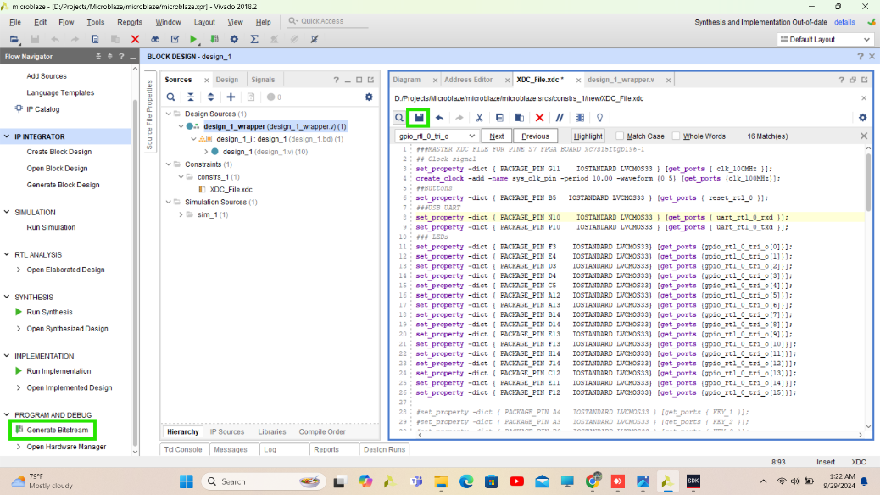

**Step 30** Click Yes Synthesis and implementation will do before bitstream. This process will take time.

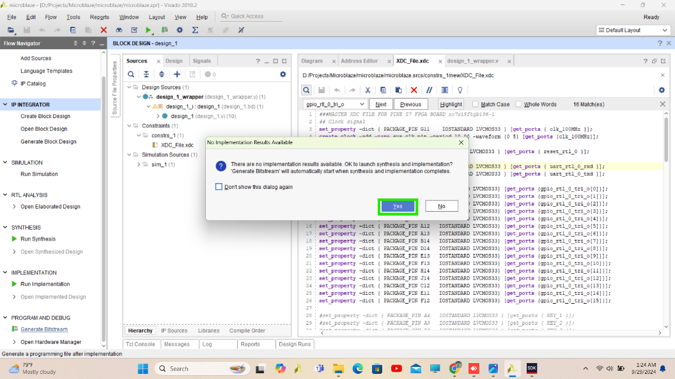

**Step 31** bitstream and other files will create on default directory in your project. This step will take some time if your processor is good (Like SSD Size) then increase no of jobs.

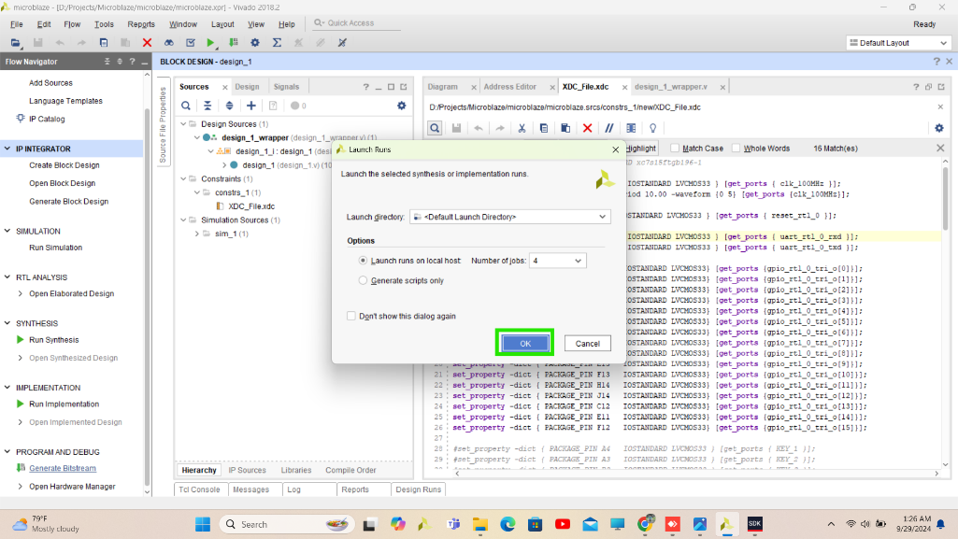

**Step 32** Bitstream generation is completed you can see implementation design by clicking **OK** otherwise click cancel.

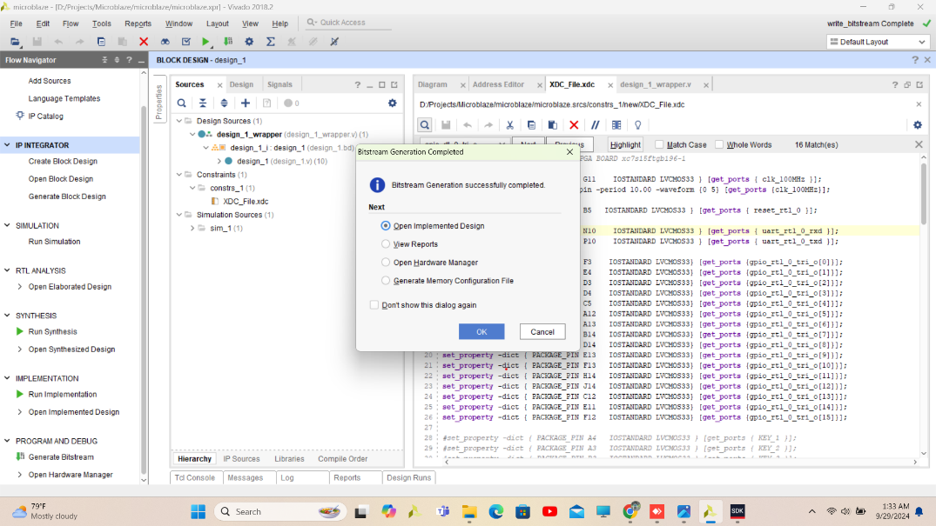

**Step 33** Before launching SDK export your design including bitstream don’t foregate to include bitstream

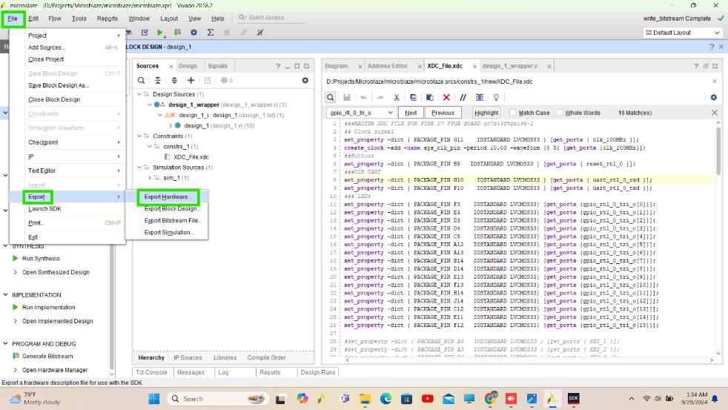

**Step 34** Before launch SDK check GPIO address in address editor

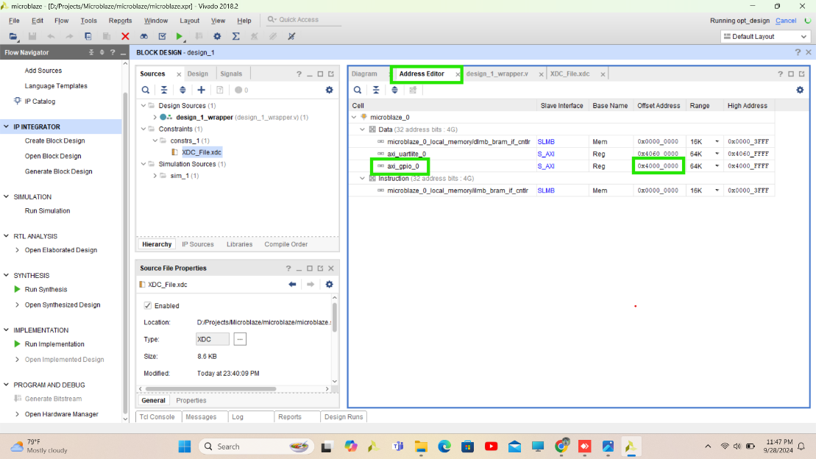

**Step 35** Launch SDK, Process of SDK and Vitis is similar

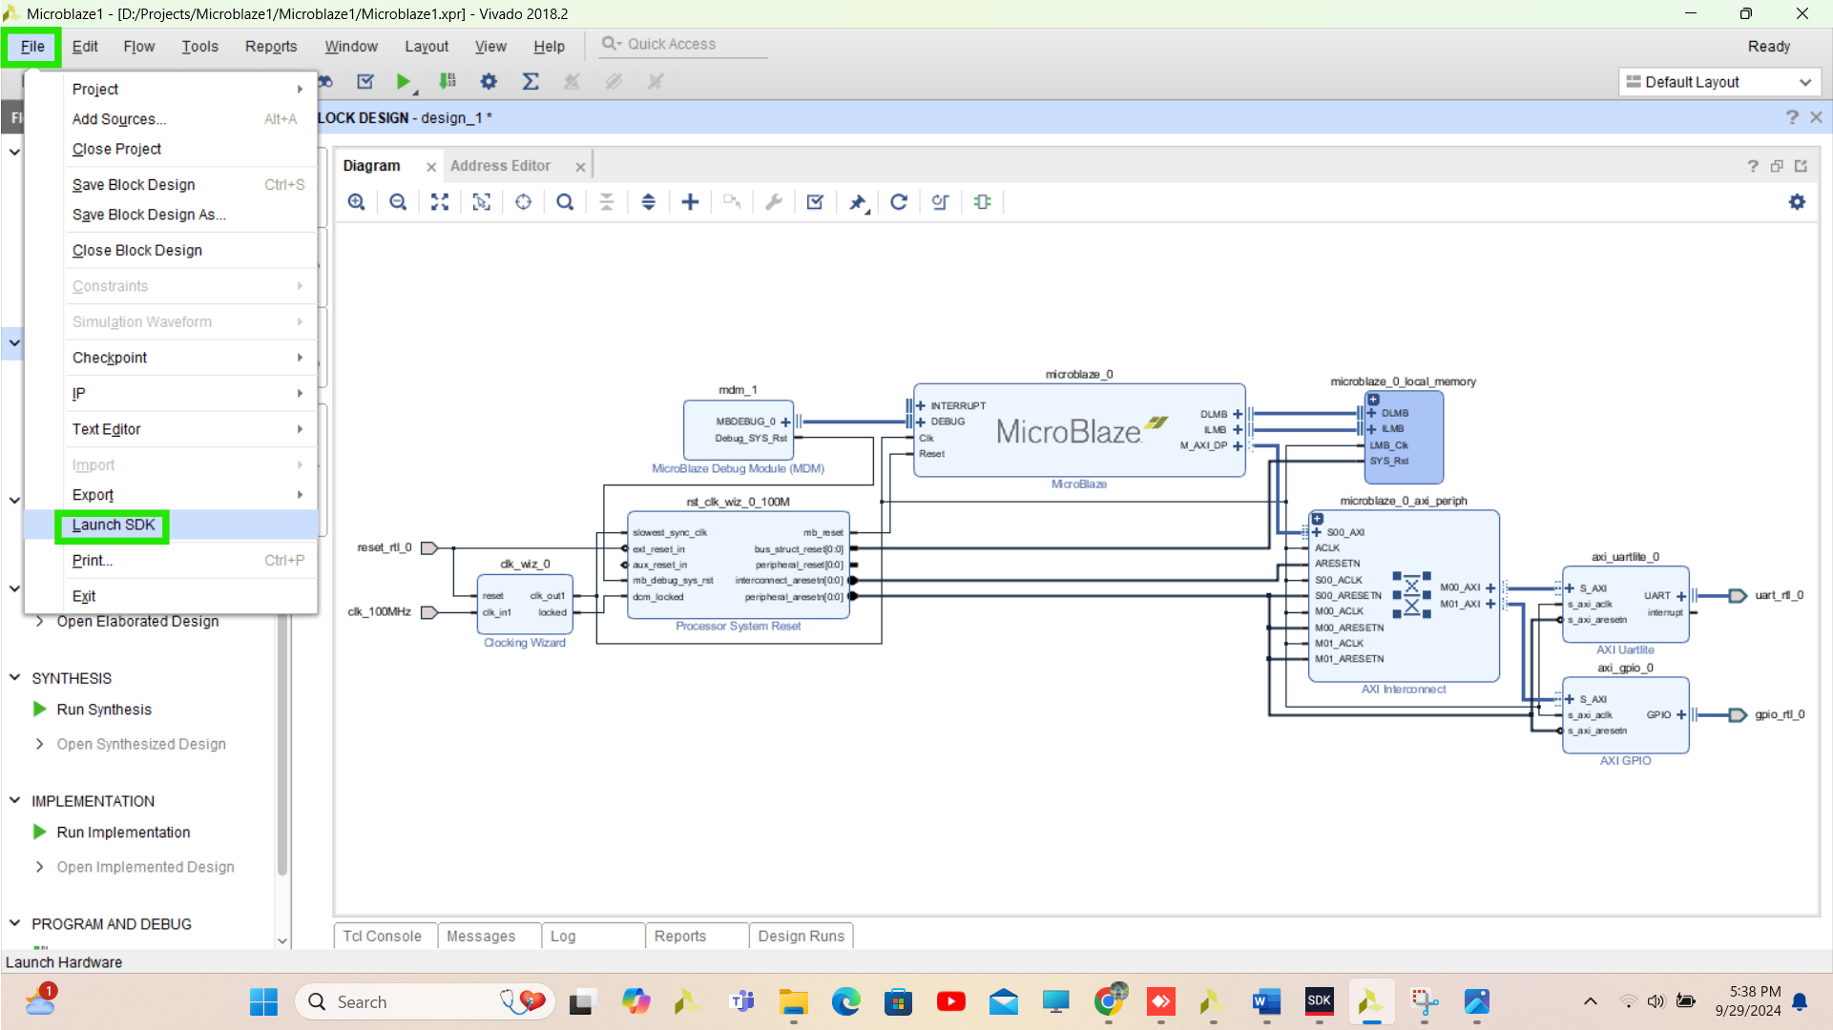

**Here all Vivado’s steps are done now follow SDK’s steps**

**Step 36** Create new Project File > New > Application Project

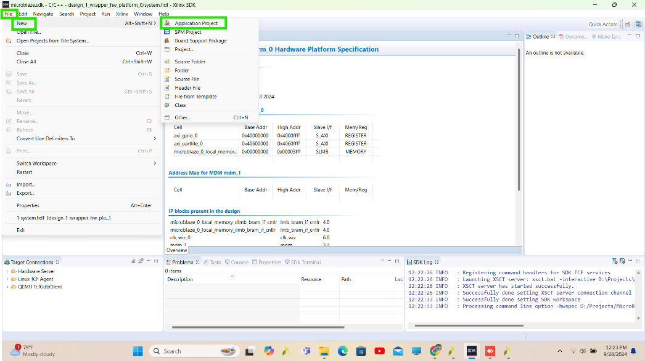

**Step 37** Specify the Project name and click on **Next**

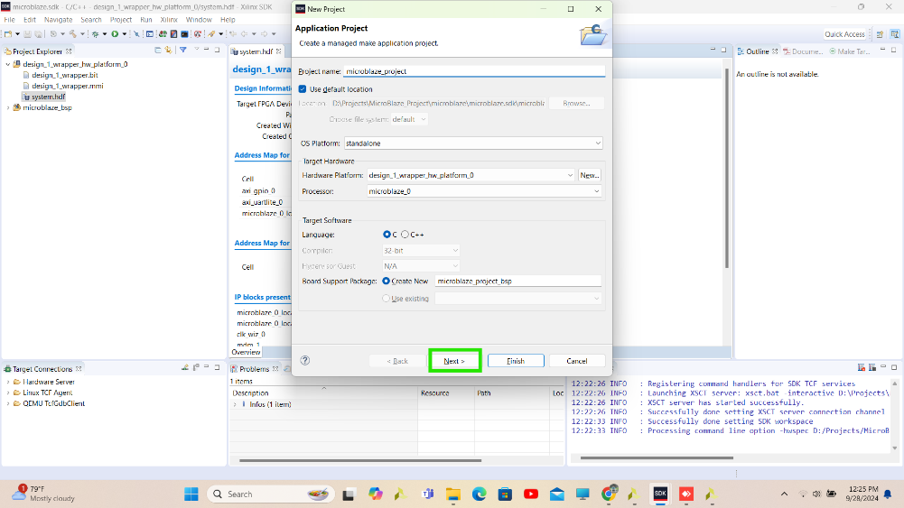

**Step 38** Use Hello word template

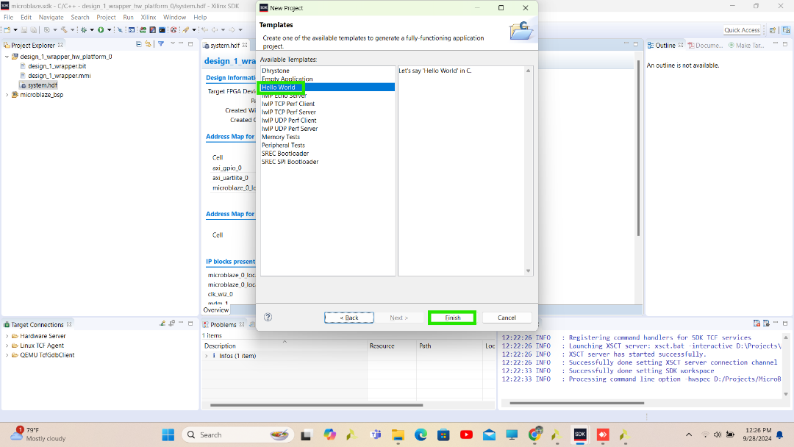

**Step 39** Open helloword.c file and write c code for LED and print statement in while loop.

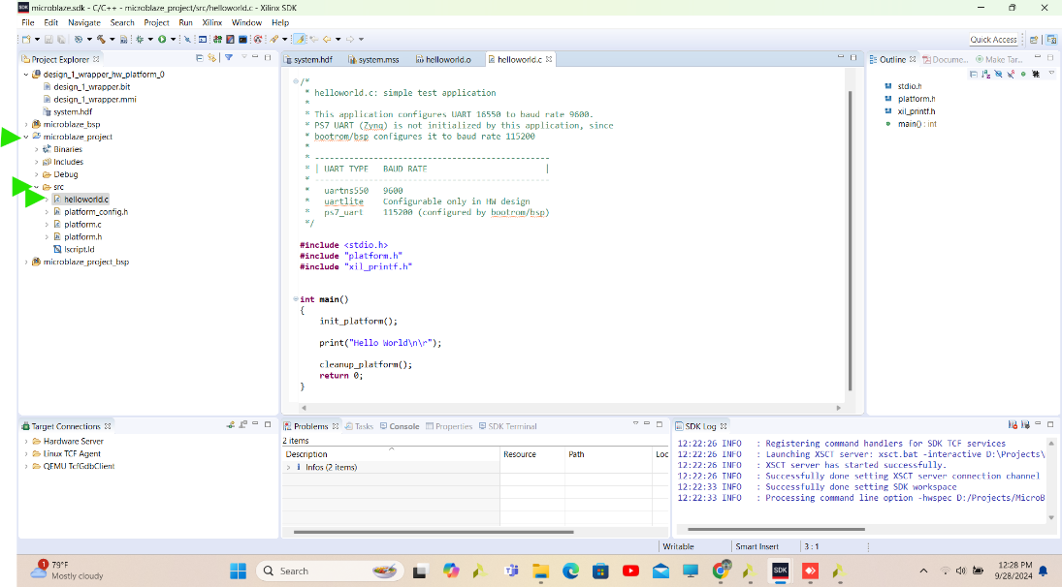

**Step 40** Here define LED with its address which is available in address editor in Vivado then right click on “microblaze_project” which is project name and build the project

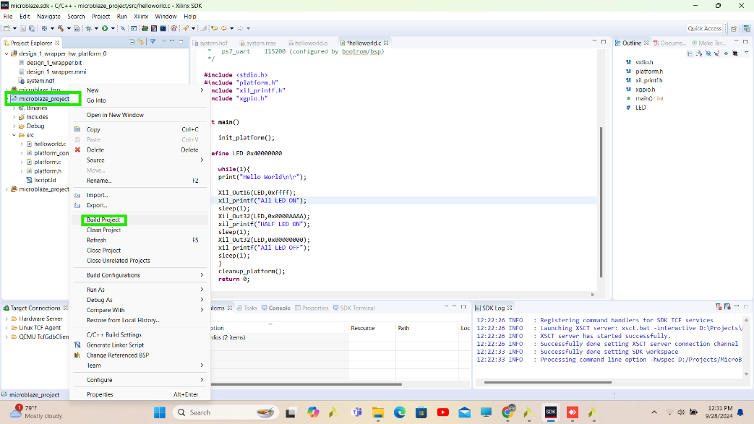

**Step 41** Before Program in FPGA first connect the hardware to laptop and select hardware.

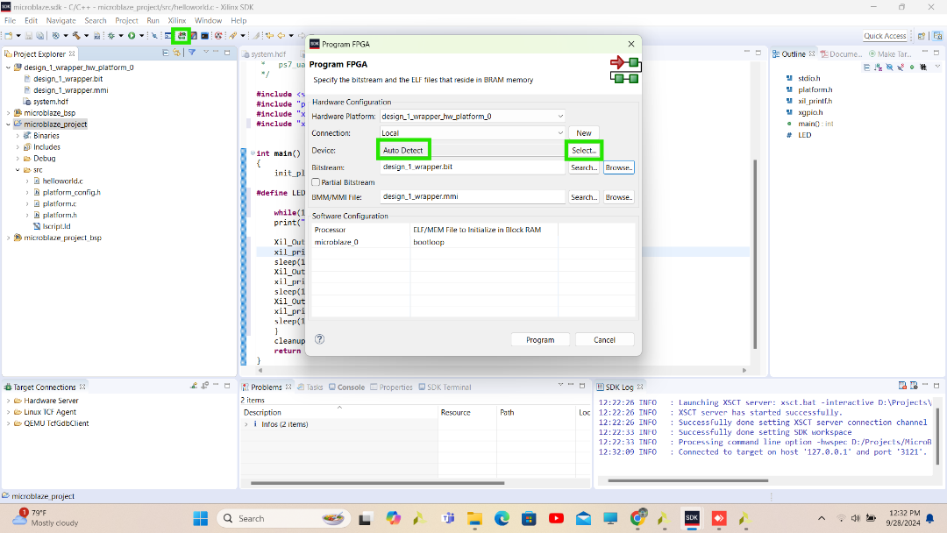

**Step 42** Check connected hardware, select and tick Auto detect

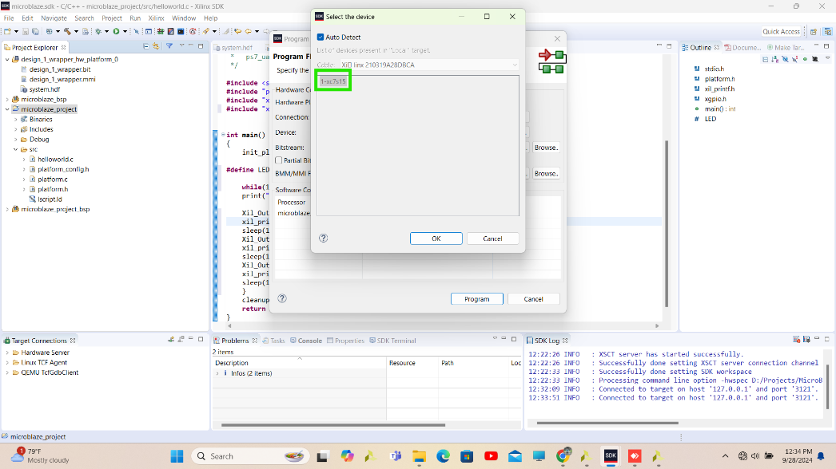

**Step 43** After detecting hardware program .bit and .BMM/MMI file in it.

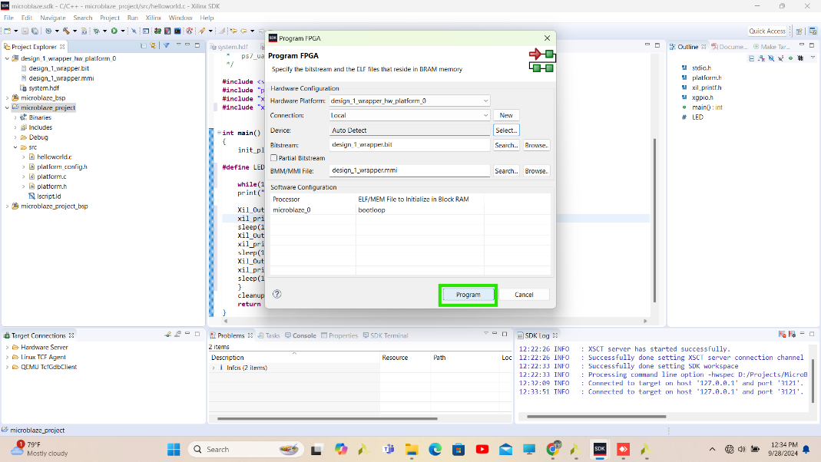

**Step 44** Run Program microblaze_project > Run As > 1 Launch on Hardware (System Debugger)

